Project Design Phase
AI FitTrack – Problem – Solution Fit Template
Date | 24 September 2026
Team ID | AI-FITTRACK-TEAM
Project Name | AI FitTrack – AI-Powered Fitness Tracking System
Maximum Marks | 2 Marks
Problem – Solution Fit Template:
Problem–Solution Fit for AI FitTrack means demonstrating that the proposed fitness tracking and AI coaching workflow directly addresses recurring problems experienced by fitness users.
Purpose:
- Solve fragmented workout tracking by centralizing records, analytics and personalized guidance.
- Increase adoption by fitting into an existing behavior: recording workouts and reviewing progress.
- Use clear product messaging around tracking, progress visibility and personalized coaching.
- Create repeat engagement through workout history, dashboard review and optional AI coaching.
- Understand current manual or fragmented tracking and replace repetitive steps with one authenticated application.
AI FitTrack Problem–Solution Fit Canvas:

Problem–Solution Fit Canvas
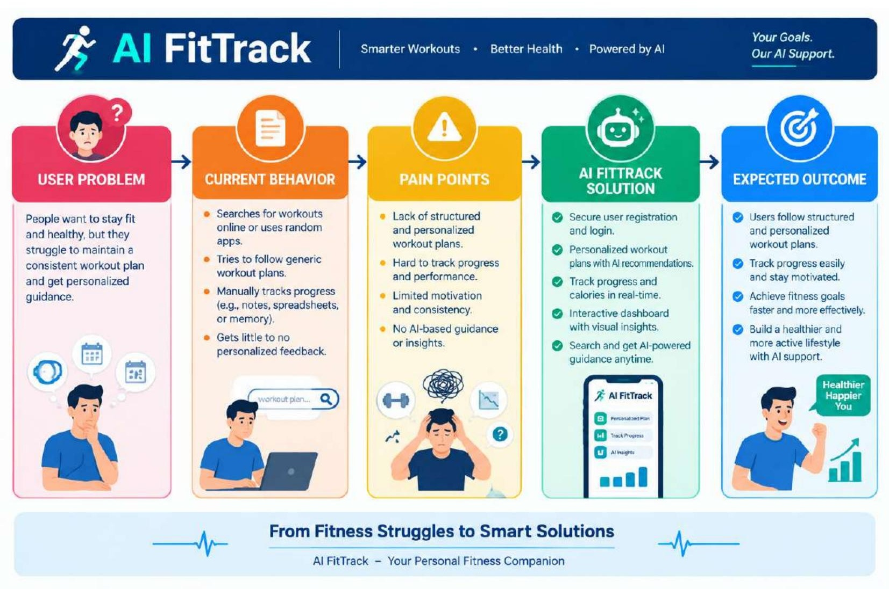
Evidence to collect: workout tracking frequency, difficulty finding historical records, time spent calculating progress, interest in personalized recommendations, and feedback on dashboard usability.
Validation Plan
• Observe a user completing registration and adding a workout.
• Measure whether search and dashboard reduce manual effort.
• Collect feedback on recommendation relevance.
• Record issues in the UAT bug log and refine the relevant user story.

